Fred Finch Youth & Family Services
6th Annual SD Charity Golf Tournament
Friday, April 17th 2020

The 2020 Fred Finch 6th Annual Charity Golf Tournament will take place on Friday, April 17^{th,} 2020 at the beautiful Rancho Bernardo Inn Golf Course and promises to be a fun-filled day for a great cause. Featuring a full day of golf and hospitality, this event will support Fred Finch and all the important work they do to positively impact the young people of San Diego.
Tournament Proceeds Support Fred Finch Youth & Family Services, a non-profit organization founded in 1891 as an orphanage on the belief that no person, regardless of circumstance, should be neglected or forgotten. We remain committed to these ideals and provide mental health services, early gang intervention, education, hope, and healing to kids and families struggling with the devastating effects of trauma, abuse, violence, and multi-generational poverty.
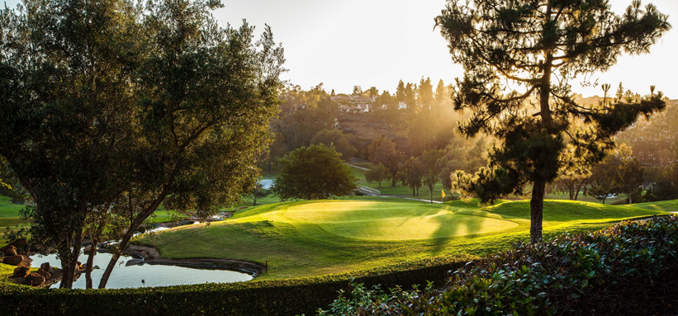
Support our work by becoming a corporate sponsor, registering to play, or donating a raffle/auction item!

Tournament Info: Schedule of Events

Fred Finch 6th Annual Charity Golf Tournament
Friday, April 17, 2020
Rancho Bernardo Inn Golf Course
17550 Bernardo Oaks Drive, San Diego, CA 92128
Register at www.fredfinch.org/golf
11:00am – Registration Begins
Putting Greens and Driving Range Open Lunch Provided
1:00pm – Tournament Begins (Shotgun Start) 6:00pm – Reception/Dinner Begins

Questions?
Contact Karina Helgeson at KarinaHelgeson@FredFinch.org or 619.792.9185
Sponsorship Opportunities

Naming Sponsor
$10,000
- Listed as “Sponsor Presents the 2020 Fred Finch 6th Annual Charity Golf Tournament” in event programs, signage, and in all pre-event publicity
- Two complimentary Guest Rooms at Rancho Bernardo Inn
- Sixteen (16) golfers in the tournament (includes golf and reception/dinner tickets)
- Eight (8) additional reception/dinner tickets following golf
- Priority seating at reception/dinner
- Three minute podium address at reception/dinner
- Entire page and cover advertisement in event programs
- All tournament entry benefits (gift bags, etc.)
- Recognition on social media

Eagle Sponsor
$5,000
- Listed as “Eagle Sponsor” in event programs, signage, and in all pre-event publicity
- One complimentary Guest Room at Rancho Bernardo Inn
- Eight (8) golfers in the tournament (includes golf and reception/dinner tickets)
- Four (4) additional reception/dinner tickets following golf
- Priority seating at reception/dinner
- One minute podium address at reception/dinner
- Half-page advertisement in event programs
- All tournament entry benefits (gift bags, etc.)
- Recognition on social media

Birdie Sponsor
$2,500
- Listed as “Birdie Sponsor” in event programs, signage, and in all pre-event publicity
- Four (4) golfers in the tournament (includes golf and reception/dinner tickets)
- Four (4) additional reception/dinner tickets following golf
- Quarter-page advertisement in event programs
- All tournament entry benefits (gift bags, etc.)
- Recognition on social media

Par Sponsor
$1,000
- Listed as “Par Sponsor” in event programs, signage, and in many pre-event publicity
- Two (2) golfers in the tournament (includes golf and reception/dinner tickets)
- Eighth-page ad in event programs
- All tournament entry benefits (gift bags, etc.)

Exclusive Hole Sponsor (One per hole)
$500
- Listed as “Hole Sponsor” on signage and in event programs
- Two (2) reception/dinner tickets

Other Sponsorship Opportunities (Contact Karina Helgeson for sponsor benefits)
- Putting Contest Sponsor
- Closest to the Pin/Longest Drive Sponsor
- Driving Range Sponsor
- Beverage/Lunch Sponsor

Player Information

Foursome
$600
- Four (4) golfers in the tournament (includes golf and reception/dinner tickets)
- All tournament entry benefits (gift bags, etc.)

Individual Player
$175
- One (1) golfer in the tournament (includes golf and reception/dinner tickets)
- All tournament entry benefits (gift bags, etc.)

Reception/Dinner/After Party Tickets
$50
- One (1) ticket to the reception/dinner following golf

For more information, please contact

Karina Helgeson - Regional Development Manager

619-792-9185 or karinahelgeson@fredfinch.org
Fred Finch 6th Annual Charity Golf Tournament
Sponsorships

Individual/Company Name: Contact:

Mailing Address: City/State/Zip:

Telephone: Other: E-mail:

Sponsorship Level |  | Golf Passes and  Dinner/Reception  Tickets | Additional  Dinner/Reception  Tickets | Hotel Rooms
- Naming Sponsor | $10,000 | 16 | 8 | 2 Rooms for  4/16 or 4/17
- Eagle Sponsor | $5,000 | 8 | 4 | 1 Room for  4/16 or 4/17
- Birdie Sponsor | $2,500 | 4 | 4 | n/a*
- Par Sponsor | $1,000 | 2 | 0 | n/a*
- Foursome (Four Players) | $600 | 4 | 0 | n/a*
- Individual Player (One Player) | $175 | 1 | 0 | n/a*
- Exclusive Hole Sponsor | $500 | n/a | 2 | n/a*
- Reception/Dinner Ticket | $50 | n/a | 1 | n/a*

Enclosed is my check, payable to Fred Finch (FF) for $ .
- Debit Card □ Visa □ Master Card □ American Express

Card Number Exp. Date Security Code

Name on Card

Signature Date

Please return completed form to Fred Finch (Contact Information below):

Tournament Info: Fred Finch 6th Annual Charity Golf Tournament
Friday, April 17, 2020
Rancho Bernardo Inn
17550 Bernardo Oaks Drive

Contact Information:
Fred Finch Youth Center (FFYC) Attn: Karina Helgeson
10174 Old Grove Rd. Suite 100
San Diego, CA 92131 Tel: 619.792.9185
Website: www.fredfinch.org

**Early Bird Special $150/Individual Player or $550/Foursome thru February 1st!

Fred Finch 6th Annual Charity Golf Tournament
Player Registration

When: Friday, April 17, 2020 (Registration begins at 11am with a 1pm shotgun start)
Where: Rancho Bernardo Inn Golf Course (17550 Bernardo Oaks Drive, San Diego, CA 92128)
Cost: $175 (includes lunch, golf, on-course beverages, dinner, prizes, and more)
Supporting: Proceeds to support Fred Finch Youth & Family Services, a non-profit organization founded in 1891 as an orphanage on the belief that no person, regardless of circumstance, should be neglected or forgotten. We remain committed to these ideals and provide mental health services, housing, education, hope and healing to kids and families struggling with the devastating effects of trauma, abuse, violence, and multi-generational poverty. Many of our youth are in the foster care system while others are struggling to leave street gangs. We offer these youth the opportunity to choose alternative paths to success through an extensive mentorship program. Fred Finch has a proven track record of success and is constantly evolving to meet the needs of our community.

Sign-Up: Complete and return the form below or register online at www.fredfinch.org/golf
Name:

Mailing/Billing Address: City/State/Zip:

Telephone: E-mail:

Participation | Price | Quantity | Total
- Individual Player (One Player) | $175
- Foursome (Four Players) | $600
- Reception/Dinner Only | $50

- Enclosed is my check, payable to Fred Finch for $
- Debit Card □ Visa □ Master Card □ American Express
Card Number Exp. Date Security Code

Name on Card

Signature Date

Paying by check? Please make payable to “Fred Finch Youth Cente” and mail to Fred Finch Youth Center
Attn: Karina Helgeson at 10174 Old Grove Rd. Suite 100, San Diego, CA 92131

A variety of affordable sponsorship packages also exist.

Visit www.fredfinch.org/golf

Contact Karina Helgeson at 619.792.9185 for more information.

*Early Bird Special $150/Individual Player or $550/Foursome thru February 1st!

